FATHER IGNATIUS MEMORIAL TRUST

The 2020 Fr Ignatius pilgrimage, through the Honddu Valley from Llanthony to Capel-y-Ffin, was due to take place on Saturday 22nd August but, like so many other events this year, it has been cancelled due to Covid-19.
Even though we cannot physically be together this August, we can nevertheless go on a spiritual pilgrimage, tracing the steps we would have taken had we been able to.
It’s just gone 11am and we gather at St David’s, Llanthony, for the first service of the day. The church, although now overshadowed by the ruins of Llanthony Abbey, dates from the 12th century, and was built on the site where St David, patron saint of Wales, established a cell.
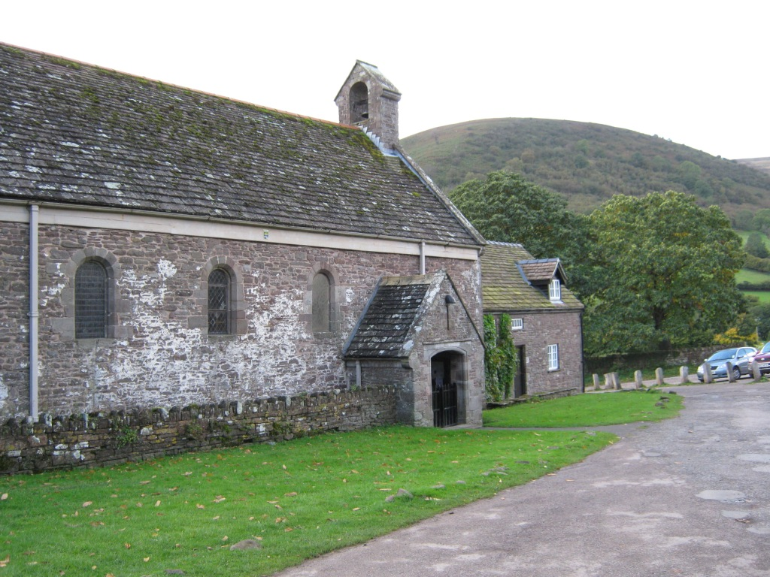
This first service is where we celebrate the Mass. While we cannot physically share the Blessed Sacrament through which Jesus gives himself to us, we can unite ourselves to him spiritually. A sacrament is the outward sign of something inward and invisible. We may not be able to receive the outer sign, but we can open ourselves to the inner grace by making an act of Spiritual Communion.
The Holy Eucharist is the most powerful and efficacious prayer from which all life in the Spirit flows, and to which all life is brought and offered to Almighty God at the altar.
It’s 11.30am and the Mass starts with the Angelus:
The Angel of the Lord brought tidings to Mary.
And she conceived by the Holy Spirit.

Hail Mary, full of grace, the Lord is with thee.
Blessed art thou among women,
and blessed is the fruit of thy womb, Jesus.
Holy Mary, Mother of God; pray for us sinners, now,
and at the hour of our death. Amen.

Behold, the handmaid of the Lord.
Be it unto me according to thy word.

Hail Mary…

And the Word was made flesh.
And dwelt among us.
Hail Mary…

Pray for us, O holy Mother of God.
That we may be made worthy of the promises of Christ.

Let us pray.
Lord God, give to your people the joy of continual health in mind and body. With the prayers of the Virgin Mary, our Lady of Llanthony, to help us, guide us through the sorrows of this life to eternal happiness in the life to come. We ask this through Jesus Christ your Son our Lord, who lives and reigns with you and the Holy Spirit, one God forever and ever. Amen
An Act of Spiritual Communion:
In the name of the Father, and of the Son, and of the Holy Spirit. Amen
Our Father,
Who art in Heaven,
Hallowed be thy name.
Thy Kingdom Come,
They will be done,
On earth as it is in Heaven.
Give us this day our daily bread,
And forgive us our trespasses,
As we forgive those who trespass against us.
And lead us not into temptation,
But deliver us from evil.
For thine is the kingdom,
The power and the glory,
For ever and ever. Amen.

Collect
Let the power of the Holy Spirit come upon me, O Lord, I beseech you: that he may both mercifully cleanse my heart and defend me from all adversities. Through Jesus Christ our Lord. Amen.
The Epistle
Revelation 3:20
Listen! I am standing at the door, knocking; if you hear my voice and open the door, I will come in to you and eat with you, and you with me.
The Gospel
St John 15:5
I am the vine, you are branches. Those who abide in me and I in them bear much fruit, because apart from me you can do nothing.
Act of Contrition
Heavenly Father,
we have sinned in thought, word and deed,
and have failed to do what we ought to have done.
We are sorry and truly repent.
For the sake of your Son Jesus Christ who died for us,
forgive us all that is past
and lead us in his way
to walk as children of light. Amen.

Act of Reception
In union, dear Lord, with the faithful at every altar of your Church where your blessed Body and Blood are being offered to the Father, we desire to offer you praise and thanksgiving. We believe that you are truly present in the Holy Sacrament. And since we cannot now receive you sacramentally, we beseech you to come spiritually into our hearts. We unite ourselves unto you and embrace you will all the affections of our souls. Let us never be separated from you. Let us live and die in your love. Amen.
Come Lord Jesus, dwell in your servant in the fullness of your strength, in the perfection of your ways, and in the holiness of your Spirit, and rule over every hostile power in the might of your Spirit and to the glory of your Father. Amen.
May the Body and Blood of our Lord Jesus Christ preserve our souls and bodies unto everlasting life. Amen.
Act of Praise and Thanksgiving
Heavenly Father, who chose the Blessed Virgin Mary to be the Mother of the promised Saviour:
fill us your servants with your grace, that in all things we may embrace your holy will and with her rejoice in your salvation; through Jesus Christ our Lord. Amen.

***
The next part of the day is the shared lunch – although some pilgrims choose to have lunch at the Abbey Hotel or the Half Moon nearby. Sharing food – an agape meal – is very much part of Christian pilgrims showing love for one another, as well as an opportunity to fuel up for the pilgrimage walk to Capel-y-Ffin.
Now it’s 1.30pm and those pilgrims who will walk along the east side of the Honddu Valley gather in front of St David’s. The walk is undoubtedly in the footsteps of monks and other travellers who journeyed from Llanthony to Hay on Wye over the centuries. Before starting, we say a prayer:
As we set out on our walk, let us ask God to support us and accept our intentions: to rejoice in the beauty of his creation and in one another’s company, to give honour to Mary, Mother of God, to St John Baptist, his forerunner, to St David and all the saints of this valley, and to his servant our Father Ignatius, and to pray for the reconciliation of divided Christians.

Let us pray.
Go before us, O Lord, in all our doings with your most gracious favour, and further us with your continual help; that in all our doings begun, continued and ended in you, we may glory your holy name and finally by your mercy obtain everlasting life; through Jesus Christ our Lord. Amen.

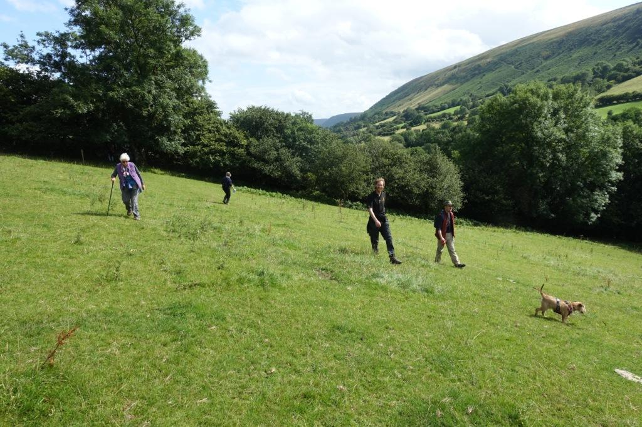

The way can be muddy, going across fields and stiles. There’s a micro-climate in the Valley so that it can be raining at Llanvihangel Crucorney and sunshine at Llanthony, and vice versa. The walk has been done by intrepid, hardy souls when it’s been raining so hard they could hardly see a few feet in front of them. On good days, it’s sunny with a slight wind, and the talk is between old friends and new, about what’s been going on in the last year, about how beautiful the valley is, about God’s creation. Three and a half miles on is the small white church of St Mary the Virgin at Capel-y-Ffin. Built in 1762 on an ancient site of worship and pilgrimage, the simple building welcomes the by now tired walking pilgrims as they join those who have chosen to drive up the ever-narrowing country lane from Llanthony for a service of Evensong.
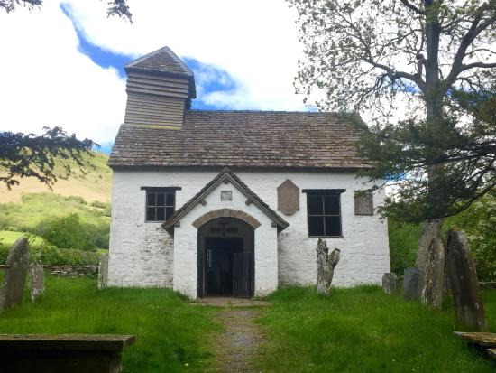
Pilgrims crowd into the church, looking at two contrasting images – the copy of the Icon of Our Lady of Llanthony, and the plain glass window on which are inscribed the words ‘I will lift up mine eyes unto the hills…’ People sit everywhere – on the pews, on the floor, all the way up the stairs to the gallery (although this wasn’t used last year after one of the seats collapsed the year before). There are even people outside and the acolytes, priest and preacher have to squeeze in as best they can.
The Service of Evening Prayer uses the Church in Wales rite, with the centrepieces of the liturgy being the Magnificat – the Song of Mary – and the Nunc Dimittis, Simeon’s prayer after seeing the infant Jesus:
MAGNIFICAT (Luke 1.46)

1 My soul doth magnify the Lord: and my spirit hath rejoiced in God my Saviour.
2 For he hath regarded: the lowliness of his handmaiden.
3 For behold, from henceforth: all generations shall call me blessed.
4 For he that is mighty hath magnified me: and holy is his name.
5 And his mercy is on them that fear him: throughout all generations,
6 He hath showed strength with his arm: be hath scattered the proud in the imagination of their hearts.
7 He hath put down the mighty from their seat: and hath exalted the humble and meek.
8 He hath filled the hungry with good things: and the rich he hath sent empty away.
9 He remembering his mercy: hath helped his servant Israel;
10 As he promised to our forefathers: Abraham and his seed, for ever.
Glory be to the Father, and to the Son: and to the Holy Spirit;
As it was in the beginning, is now, and ever shall be: world without end. Amen.

NUNC DIMITTIS (Luke 2.29)

1 Lord, now lettest thou thy servant depart in peace: according to thy word.
2 For mine eyes have seen thy salvation: which thou hast prepared before the face of all peoples.
3 To be a light to lighten the Gentiles: and to be the glory of thy people Israel.
Glory be to the Father, and to the Son: and to the Holy Spirit;
As it was in the beginning, is now, and ever shall be: world without end. Amen.

We listen to the sermon before the thurifer and acolytes lead the priest, preacher and pilgrims out of the church for the walk up the lane to the Abbey Church built by Father Ignatius, singing songs of praise to Mary as we go. It can sometimes be a bit difficult dodging the ‘mess’ left by the ponies from the trekking stables by the monastery, but then we’ve all been advised to wear stout footwear!
It’s in this walk, the last of the day for most, and the prayers at the statue of Our Lady of Llanthony that Mary really takes centre stage. We walk to the place where, on August 30, 1880, four ‘monastery boys’ who were playing in the meadow below the monastery buildings saw a female figure apparently gliding across the surface of the field. They identified her as the Blessed Virgin Mary and the apparition was seen three more times over the following two weeks.
We stop at the Wayside Calvary, just around the corner from the monastery buildings, which was dedicated on August 30, 1936 – 56 years after the first apparition – to hear from the Gospel of John.
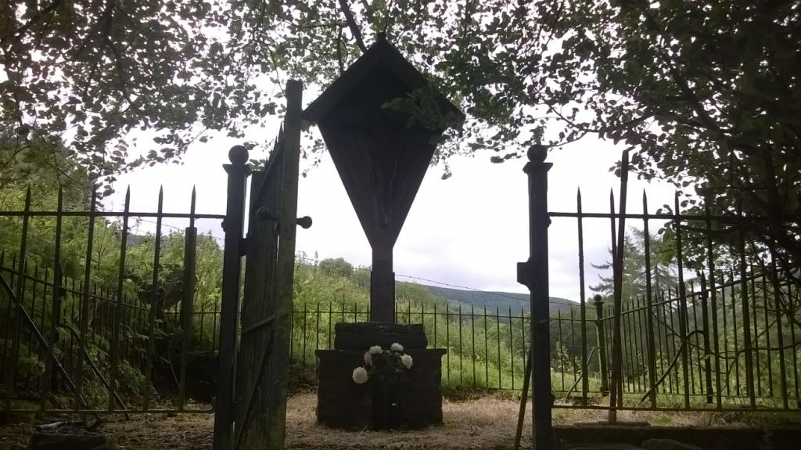
Near the cross of Jesus stood his mother and his mother’s sister, Mary the wife of Clopas, and Mary of Magdala. Seeing his mother and the disciple he loved standing near her, Jesus said to his mother, “Woman, this is your son.” Then to the disciple he said, “This is your mother.” And from that moment the disciple made a place for her in his home.

Let us pray:
Father, as your Son was raised on the Cross, his Mother Mary stood by him, sharing his sufferings.
May your Church be united with Christ in his suffering and death and so come to share in his rising to new life, who lives and reigns with you and Holy Spirit, one God, for ever and ever. Amen.

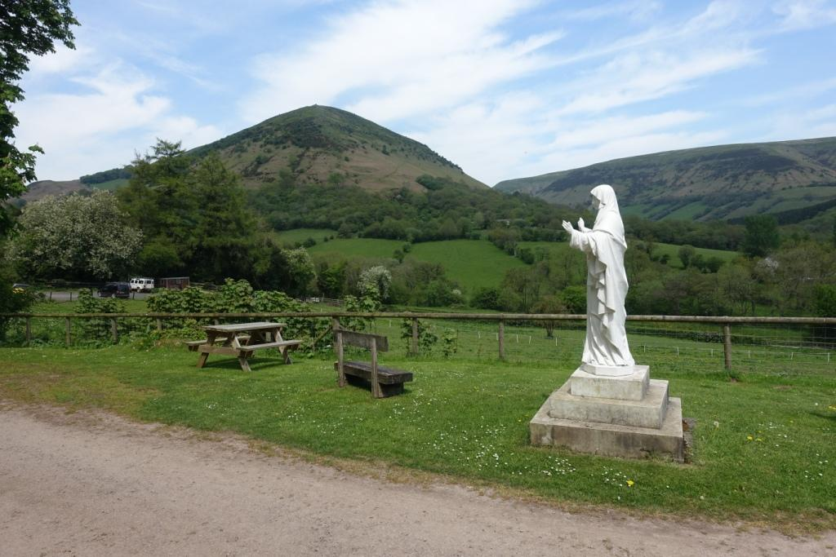

On round the corner, past curious horses just back from another trek, the pilgrims reach the Statue of Our Lady of Llanthony and we sing the Salve Regina :

Hail, holy Queen, Mother of Mercy;
hail, our life; our sweetness and our hope!
To thee do we cry, poor banished children of Eve;
to thee do we send up our sighs,
mourning and weeping in this vale of tears.
Turn then, most gracious Advocate,
thine eyes of mercy toward us;
and after this our exile,
show unto us the blessed fruit of thy womb, Jesus.
O clement, O loving, O sweet Virgin Mary.

And we pray:
Almighty God, who by the co-operation of the Holy Spirit didst prepare the body and soul of the glorious Virgin Mother Mary to become a dwelling place meet for thy Son:
Grant that, as we rejoice in her commemoration, so by her gracious intercession we may be delivered from present evils and from everlasting death.
Through the same Jesus Christ our Lord.

We offer prayers in thanksgiving, for the sick, for those in need, for the departed:

O Holy Mary, help those in need, give strength to the weak, comfort the sorrowful, pray for God’s people, assist the clergy, intercede for religious. Mary all who seek your help experience your unfailing protection. Amen.

It is then but a short step to the door of the Abbey Church and the final act of devotion, and we sing a hymn written by Fr Ignatius joining past and present:

Let me come closer to thee, Jesus; Yea, like a fountain precious, Jesus,
Oh! closer day by day, Make me and let me be;
Let me lean harder on thee, Jesus, Keep me and use me daily, Jesus,
Yea, harder all the way. For thee, and only thee.
Let me show forth thy beauty, Jesus, In all my heart and will, O Jesus,
Like sunshine on the hills. Be altogether King.
Oh! let my lips pour forth thy sweetness Make me a loyal subject, Jesus,
In joyous, sparkling rills. To thee in everything.
Thirsting and hungering for thee, Jesus,
With blessed hunger here,
Longing for home in Zion's Mountain,
No thirst, no hunger there.
Fr Ignatius O.S.B.
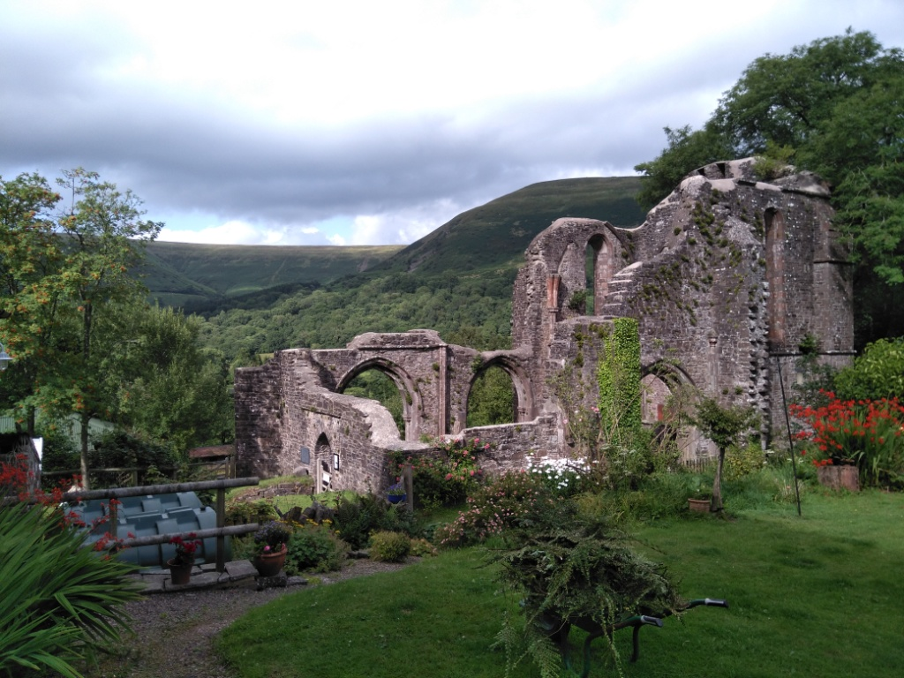

At door to the church, now in ruins, we say prayers before the burial place of Fr Ignatius, set in the centre of the nave:

Stir up, O Lord in thy Church, the spirit that quickened Benedict the Abbot; that being filled with the same spirit we may be zealous to love what he loved and to put into practice what he taught. Through Jesus Christ our Lord. Amen.

Grant to us, Lord, we beseech thee, perseverance in thy service; that the people who serve thee may be increased in our times both in number and goodwill. Through Jesus Christ our Lord. Amen.

Almighty God, by whose grace Ignatius, kindled with the fire of thy love, became a burning and a shining light in the Church, inflame us with the same spirit of godliness and love, that we may ever walk before thee as children of light. Through Jesus Christ our Lord. Amen.

And then, after a long day, come rain or shine, we step up to the garden of the Monastery – now a private house with holiday accommodation – for a cup of tea and piece of cake, courtesy of Andrew and Sue Knill. Never did tea and bara brith taste so good.

The final act is to make sure that everyone who wants one has a lift back to Llanthony where they left their cars – some pilgrims walk back along the road.

It’s about 5.30pm, back in Llanthony, with tired legs and light hearts, slipping into cars either hot from the sun or sitting in puddles of rainwater. There are calls of ‘It’s been a great day’ and ‘See you next year’.

The Trustees very much hope that the pilgrimage does take place next year, on the Saturday of the weekend before the August bank holiday, and that we will ‘see you next year’. In the meantime, keep safe.

Every blessing to all Friends of the Father Ignatius Memorial Trust

Caroline Woollard, Trust Chairman
Peter Davies, Trust Secretary, 43 St Helen’s Road, Abergavenny NP7 5YA Tel 01873 858762
17/08/2020

